# Connecting the Pi to its interfaces

1. Put the SD card into the SD slot
2. Connect the HDMI interface to the monitor and the Pi
3. Plug in the mouse and keyboard into the two USB slots
4. Plug in the Ethernet cable to the Pi
5. Plug in the power source into the micro-USB connector – It should now be booting up!

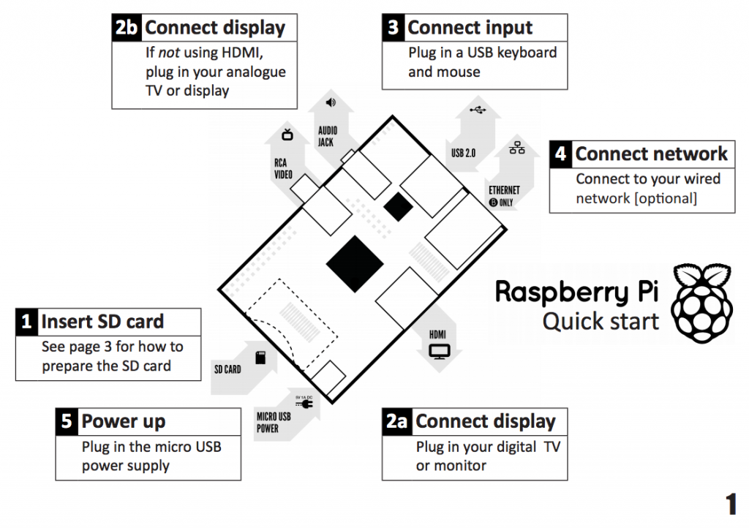

NB

* The Pi is heavily reliant on a good, reliable power supply. Either ensure that you have a very good quality PSU or connect it to a powered USB supply.
* Similarly, if you connect a USB Hub to the Pi, it must be a Hub with its own power supply and this too must be a good quality unit.
* If the keyboard, mouse or Wi-fi device appears to be temperamental, it is probably because of underpowered power supplies.